Quantifying the Targeting Performance Benefit of Electrostatic Haptic Feedback on Touchscreens

【Summary】：

First quantitative evaluation of how electrostatic force feedback can be used to enhance targeting performance on touch screens

【Static electricity feedback】:

1. Touch screen with dynamic electrostatic friction is an attractive low-latency solid-state haptic feedback technology. Work to date has focused on minimal perceptual differences, texture rendering, and fingertip surface models.
2. However, to date, no work has been able to quantify how electrostatic feedback can be used to improve user performance, especially in terms of target positioning where virtual objects rendered on touch screens can provide tactile feedback. Our results show that electrostatic haptic feedback can increase target speed by 7.5% compared to traditional flat touch screens.

【Research based on ultrasound same as this article】: [3,12]

【Experiments】：

Procedure：

step1- (center edge background) * (physics + static) + nothing put in the object area

step2-Experiment using Fitts-style dragging process [12]

step3-For each experiment, participants first touch the red object to select it. Participants then slid their fingers across this distance and placed the red object on the target. (Used to simulate dragging in actual operation)

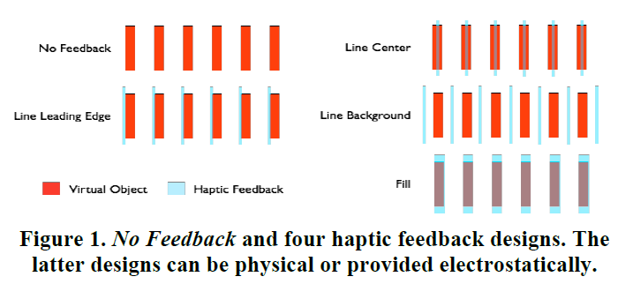 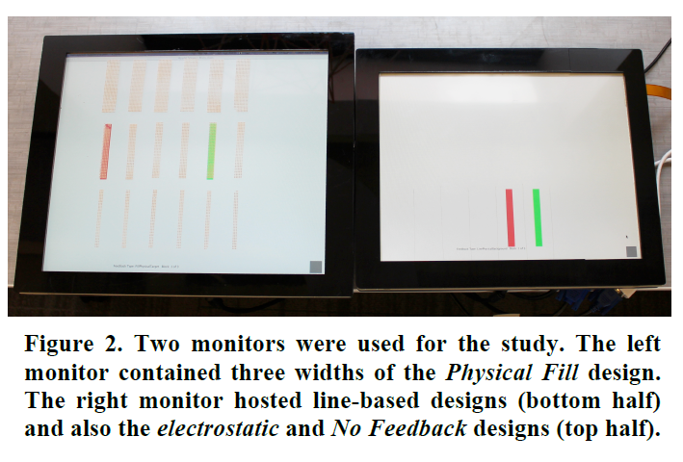

Results:

1. time：Physical Line Background/Physical Line Leading Edge < Electrostatic Fill < No Feedback
2. The error rate did not show a significant difference in the above tactile feedback experiments

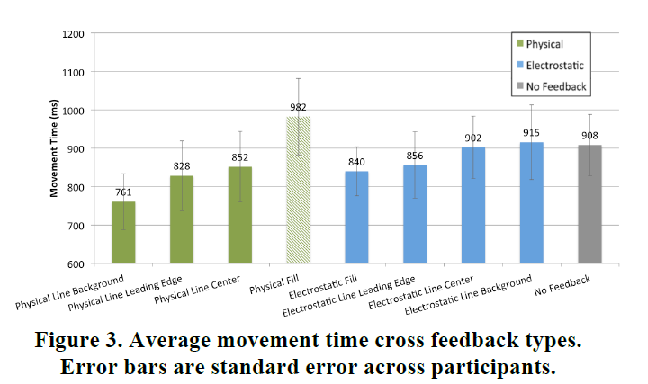 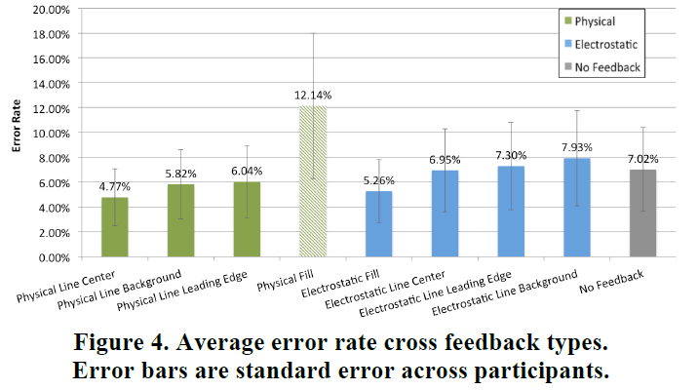

Conclusion: All haptic designs are better than no feedback (ie, lower slope values). Second, tactile feedback provided by physical characteristics always produces lower slope values than feedback provided by static electricity.

【Subjective analysis】：

**Advantage:** Study the impact of haptic feedback on object positioning

1) Comparison of the experimental results under the conditions of transparent sticker, electrostatic feedback, and no feedback

2) At the same time, the experimental effects of setting feedback in different areas (center/edge/background) of the object are studied.

3) Experiment by dragging the object and simulating the sliding operation on the screen. And use the error rate and time of the drag as a metric.

**Disadvantages:** Experimental data shows that physical fill may affect the screen's induction, but it is not stated in the article whether electrostatic feedback will also affect the recognition of capacitive screens. Therefore, it is possible that the conclusions finally reached are not accurate enough.

**Next:** At the same time, more in-depth research can be carried out based on the ideas of this article, such as: 1) Research based on the comparison of different physical materials. 2) With different swipes, click on the task to study.

【Important Reference】:

1. Amberg, M., Giraud, F., Semail, B., Olivo, P., Casiez, G. and Roussel, N. STIMTAC: a tactile input device with pro-grammable friction. In Proc. UIST '11 Adjunct, 7-8.

2. Bau, O., Poupyrev, I., Israr, A. and Harrison, C. Tes-laTouch: Electrovibration for Touch Surfaces. In Proc. UIST '10, 283-292.

3. Casiez, G., Roussel, N., Vanbelleghem, R. and Giraud, F. Surfpad: riding towards targets on a squeeze film effect. In Proc. CHI '11, 2491-2500.

5. Giraud, F., Amberg, M., Lemaire-Semail, B., Merging two tactile stimulation principles: electrovibration and squeeze film effect. In Proc. WHC '13, 199(203), 14-17.

12. Lévesque, V., Oram, L., MacLean, K., Cockburn, A., Mar-chuk, N.D., Johnson, D., Colgate, J.E. and Peshkin, M.A. Enhancing physicality in touch interaction with programma-ble friction. In Proc. CHI '11, 2481-2490.

13. Mallinckrodt, E., Hughes, A. and Sleator, W. Perception by the Skin of Electrically Induced Vibrations. Science, 1953. 118(3062), 277-278.

14. Meyer, D.J., Peshkin, M.A. and Colgate, J.E. Fingertip fric-tion modulation due to electrostatic attraction. World Haptics Conference 2013, 43(48), 14-17.

15. Meyer, D.J., Wiertlewski, M., Peshkin, M.A., and Colgate,

J. E., Dynamics of ultrasonic and electrostatic friction modu-lation for rendering texture on haptic surfaces, Haptics Sym-posium, 2014. 63(67), 23-26.

16. Mullenbach, J., Shultz, C., Piper, A., Peshkin, M. and Col-gate, E. Surface Haptic Interactions with a TPad Tablet. In Proc. UIST '13 Adjunct, 7-8.

18. Poupyrev, I., Okabe, M. and Maruyama, S. Haptic feedback for pen computing: directions and strategies. In CHI EA '04, 1309-1312.

21. Xu, C., Israr, A., Poupyrev, I., Bau, O., and Harrison, C., Tactile display for the visually impaired using TeslaTouch. CHI EA '11, 317-322.